Rowan Elijah Feldhaus Transgender Advocacy Award

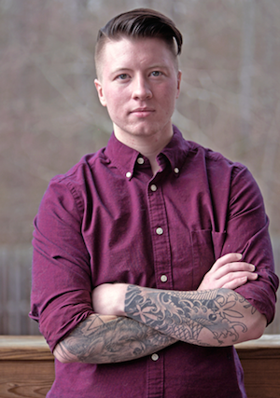
Amount: 200.00
Award Applications Accepted: April 1-May 31
Award Presented: June during Augusta Pride, exact time and date TBD

In honor of the life of Rowan Elijah Feldhaus, this award honors an individual or organization that has made meaningful contributions to transgender, gender variant, transsexual, genderqueer, and gender questioning people in the CSRA over the last 12 months. The Transgender Advocate of the Year Award winner will have demonstrated contributions that resulted in the creation or improvement of an inclusive, respectful, and safe climate for the transgender community and their allies, promoting acceptance, equality and diversity in the CSRA community.

Rowan Elijah Feldhaus, 25, died after complications surfaced in the wake of a May 4, 2017 surgery that was part of his gender transition. Rowan’s grace, quiet dignity, strength and self-assurance were an inspiration to many. After having been discriminated against by a judge who refused to allow him to change his name because he was transgender, Rowan wanted to make sure that no other transgender person was similarly insulted and objectified. Because Rowan stood up, Georgia judges are now required to allow people to change their names without bias. Lambda and ACLU of Georgia facilitated an appeal in the Georgia Court of Appeals and won. Georgia Equality honored Feldhaus during its 12th Annual Evening for Equality in June 2016, and Feldhaus had become a member of the organization's board. The impact of his courage will continue to be felt by transgender and other gender non-conforming individuals in Georgia for many years to come.
Biography content from: http://www.projectq.us/atlanta/young_transgender_man_who_fought_georgia_judge_dies?gid=18378
Rules:
1. Only those residing or working within the CSRA during the year prior to the award announcement shall be eligible.
2. No award will be awarded to the same person or organization in consecutive years.
3. Only one award will be given per year; however, it is not required that an award be made every year.
4. Anyone from the community may make nominations, final decision rests with the Equality Clinic Board.

APPLICATION
Rowan Elijah Feldhaus Transgender Advocacy Award

Nominator Name (self-nominations permitted):

Nominator Email:

Nominee Name (person or organization):

Nominee Contact information (email, phone, and address, if available):

What has this person or organization done to deserve this award? Please describe and include attachments (news articles, examples of work, etc) that provide documentation of contributions and impact:

Nominations are due by May 31st, 2018. Please send nominations via email to: Lara Stepleman, Equality Clinic Co-President, lara.stepleman@gmail.com

